Investigating the year round plan of the polytunnel in Transition Year 2016/2017
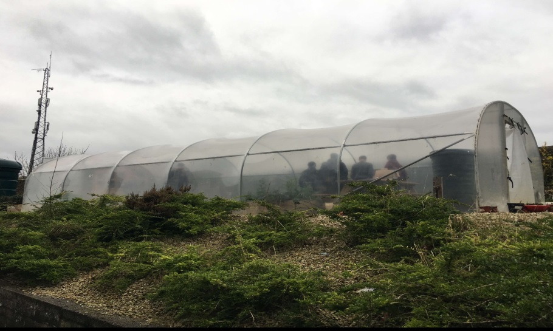

By Lucy Bruton and Sarah Quirke, 4C

Advantages of the polytunnel:
- Offers an all year round weatherproof space for gardening and other classes.
- Allows crops to be grown in Ireland that would not grow or survive outside.
- Extends the growing season right through the winter.

Plan Of...
Autumn:
After our three month summer holidays, the polytunnel is in need of a clean out, this means we cut all the weeds, make sure each crater of soil is raked and ready to be filled with seeds for new plants and vegetables. From weeding the plants, the soil that contained the weeds will be put into the compost bin. Next we planted potatoes, salads, mange tout, herbs, carrots and tomatoes. When the plans are sown we can then do our weekly routine of watering and spraying homemade and natural weed control, so it doesn't harm the plants. The natural weed control is made from garlic, water and a little bit of washing up liquid. We also have a shed next to the polytunnel where more plants and herbs are grown.
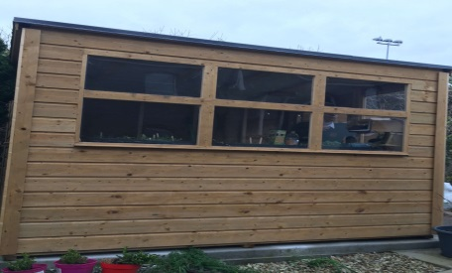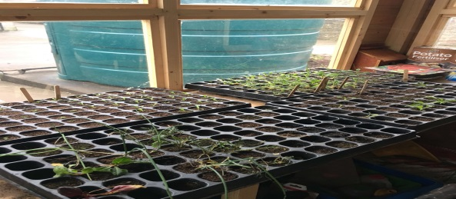
Pictured above from left to right: the shed next to the polytunnel and the plants being grown in the shed.
Winter:
In the winter, we keep doing our weekly watering and spraying weed control. During this time we also make sure that the polytunnel is kept clean by cutting the weeds that may grow in the sides of the polytunnel, in preparation for spring.
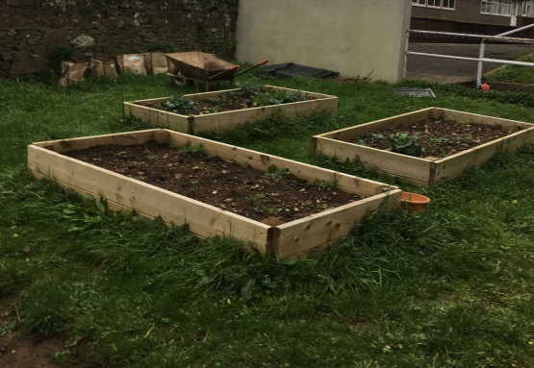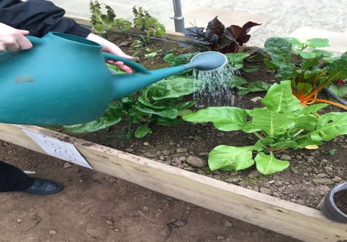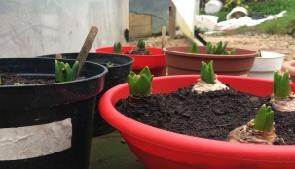
Pictured above from left to right: craters with plants being grown, watering the plants, bulbs peeking out from soil.
Spring:
In the spring we harvest the autumn sown vegetables, see or plant out salads, tomatoes, cucumbers, aubergine and oriental greens. We also continue our weekly routine of watering and spraying weed control over each of the craters containing the items that are being grown. We hope to build a sensory garden next to the polytunnel during the months of spring.
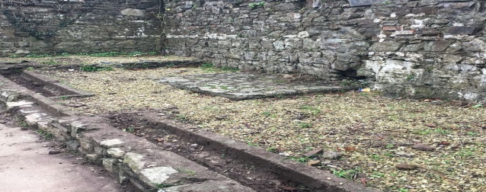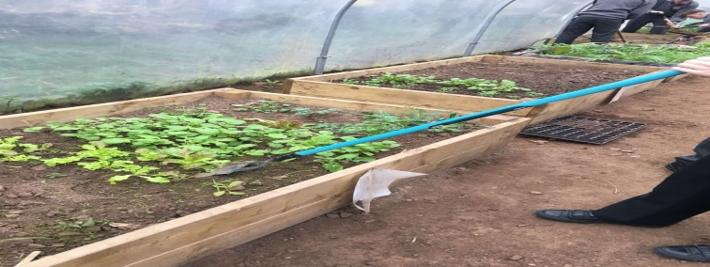
Pictured above from left to right: the area where we plan to build the sensory gardening and hoeing the plants.
Summer:
In May, we harvest the second crops grown in spring. During the school holidays there is low maintenance needed as some crops may be ready before September but the tunnel will need watering throughout summer months. After the summer is over the next year of Transition Years will take over the responsibility for the polytunnel, they will need to weed the beds and add the remains to the compost bin.
Pictured above from left to right: the compost bin and lettuce plants fully grown.
