 |  |  | How to be more Biodiverse at home  Reduce or QUIT the use of pesticides and fertilizers in your gardens  Invest and grow wildlife friendly gardens/patios or balconies and choose wildlife-friendly fencing to allow some access  Reduce, reuse, and recycle, with an emphasis on REDUCE. (Buy less non-essential stuff).  Use environmentally friendly personal and household cleaning products, for example, distilled vinegar  Buy local, organic food and drink. Ask for it if the shops don’t stock it. Grow your own if you are able or buy direct from small holdings.  Buy sustainably harvested seafood, which avoids ‘by-catch’ of other species  Conserve energy in your home.  Reduce single-person car use. Car pools, public transport, walking, and bicycling are also options  Try to use renewable forms of energy. By reducing your energy demand, you reduce both carbon dioxide release into the atmosphere, which contributes to climate change, and disturbance of habitat for fossil fuel exploration and extraction. And you make savings
  At Coláiste Muire we strive to protect the environment in every way possible
  We are currently in the process of obtaining a green flag for biodiversity.
  We have previously received green flags in
  - Litter and Waste
  - Energy
  - Water
  - Travel
  Coláiste Muire
    - Green flag committee biodiversity
  

 |  |  | As part of our pledge for a green flag we must try and promote biodiversity in the wider community.  We hope that you will have learned a lot from your visit and try promote biodiversity in your own home  Further Information  Check out the national green flags website at www.greenschoolsireland.org  Or our own website  www.colaistemuiregreenschoolscommittee.yolasite.com  Also download the app “Map of Life” on smart phone  Learn about the different species of animals in your area.  
  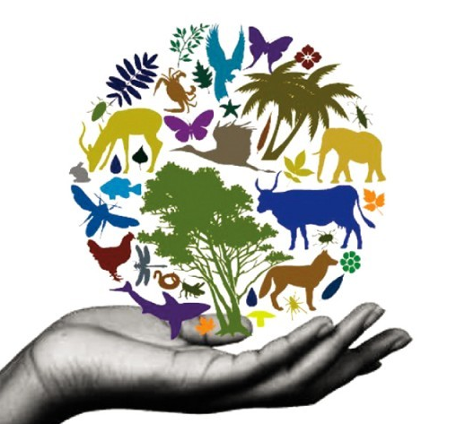
  Why is Biodiversity so important?
  Gives us the air we breathe
  Provides us with food, medicine & fuel
  Pollination & biological control
  Protection from soil erosion & flooding
  Recycling of nutrients (composting)
  Where do we see Biodiversity around us?
  Food Medicine
  Furniture Clothes
  Trees Insects
  Plants Animals
  “Biodiversity is the huge variety & variation of life that surrounds us, from the tiniest bugs to the biggest whales in the sea”
  What is happening to Biodiversity?
  Litter and pollution cause the death of millions of wildlife each year
  Habitat loss, fragmentation & destruction changes the conditions needed for particular plants and animals to survive
  Climate Change can cause habitats to become uninhabitable to some species
  Invasive (alien) species destroy natural eco systems
  Over-exploitation can cause the removal of plants and/or animals from a habitat to the point of no return!

