If You Chew, What You Do, Is Up To You!
As many students in this school would know, chewing gum and the damage it does to our classrooms, hallways etc is a huge problem, despite the fact that chewing gum has been banned.
3 members of our environmental studies class went around the school and took photos of several hallways and classrooms. These are the results:
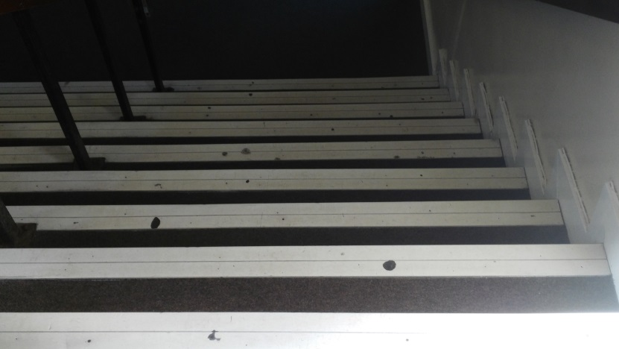
The stairs in the old building
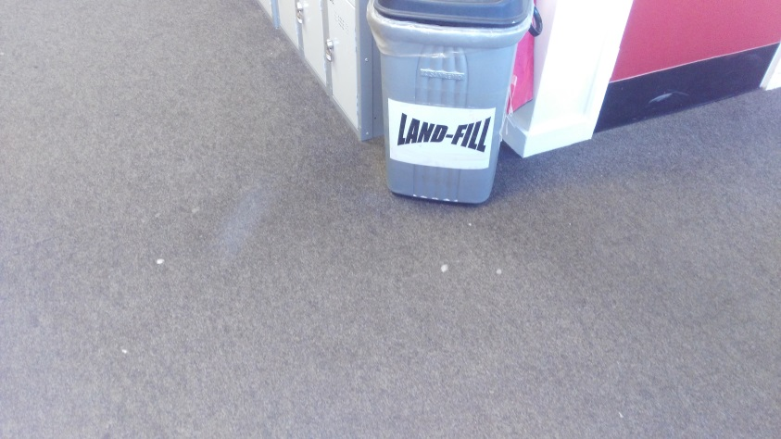
The middle floor by the lockers-note the gum spat out AROUND the bin
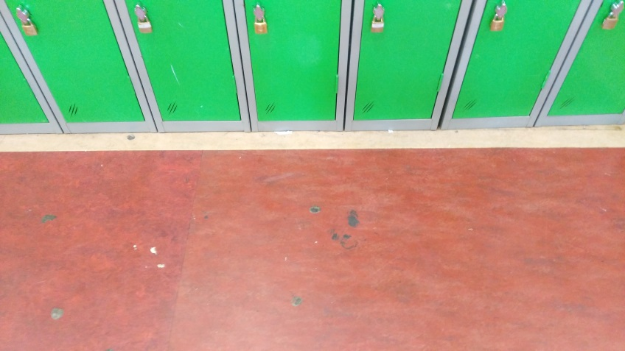

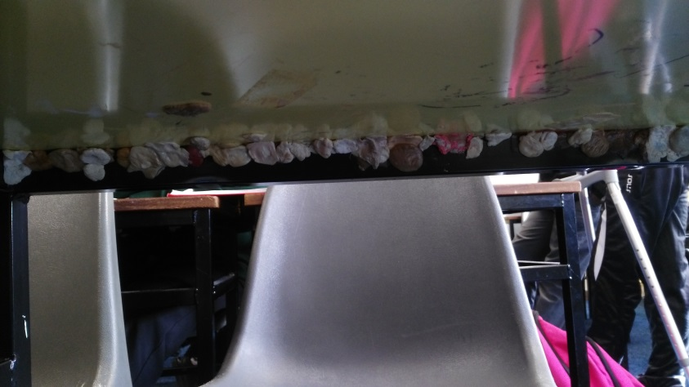
The dining assembly Under a table in room 9
This is totally disgusting and costs the school thousands each year to replace chewing gum damaged carpets and tables.
To raise more awareness, we have researched some harmful effects of chewing gum on the body:
- It can increase your junk food intake, as the minty taste makes fruit and veg taste bitter, but has next to no effect on junk food.
- May trigger Jaw Muscle Imbalance
- Gastrointestinal problems, as your stomach is getting ready for food that isn't coming and the acids are building up
- Tooth damage as you're essentially bathing your teeth in sugar
- It can release mercury from fillings, which is toxic
- It is also linked with headaches
We also have some ingredients to avoid:
- BHT (Butylated Hydroxytoluene)
- Calcium Casein Peptone (Calcium Phosphate)
- Gum Base
- Titanium Dioxide.
We are hoping after providing this information that students in our school will think twice before chewing!

