Bug Hotel
Éaibhín Gormley, Katie O' Connor, Zoë​​ Scannell
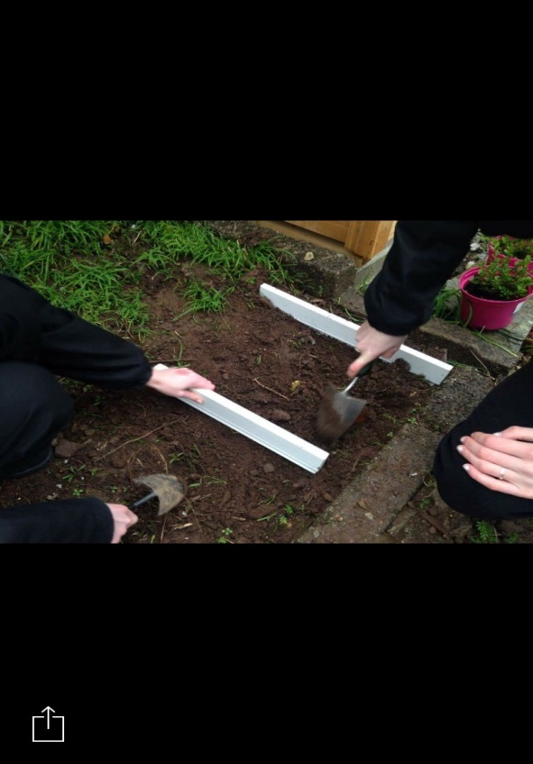
Stage 1: Laying down the foundations.
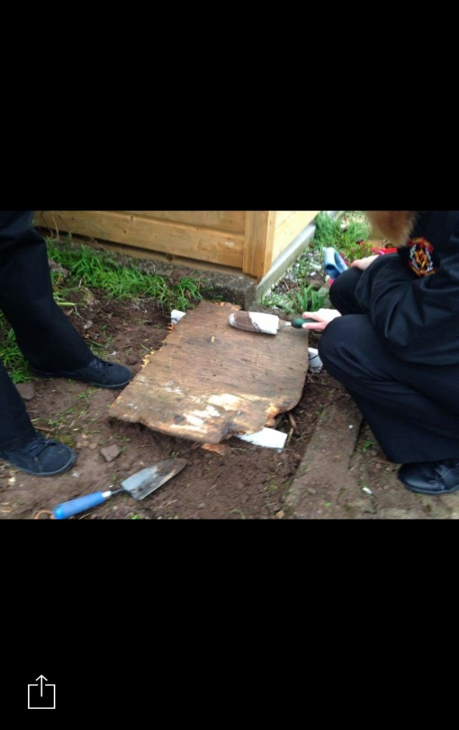
Stage 2: Starting the second layer.
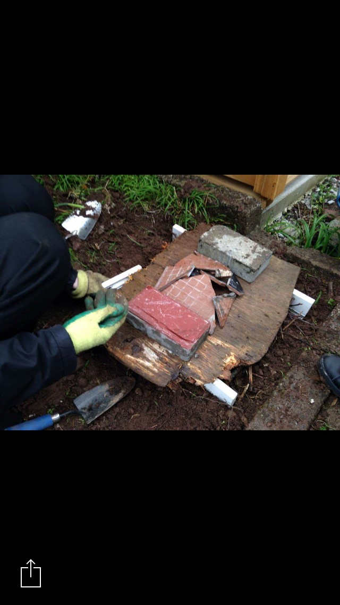
Stage 3: Filling the second layer with bricks and tiles.
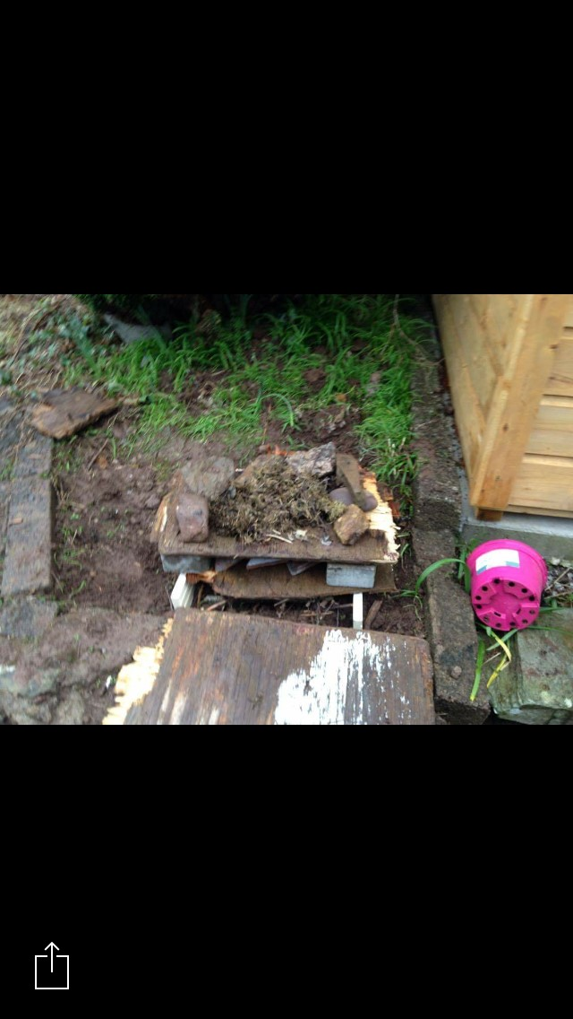
Stage 4: Applying grass and moss to the third layer.
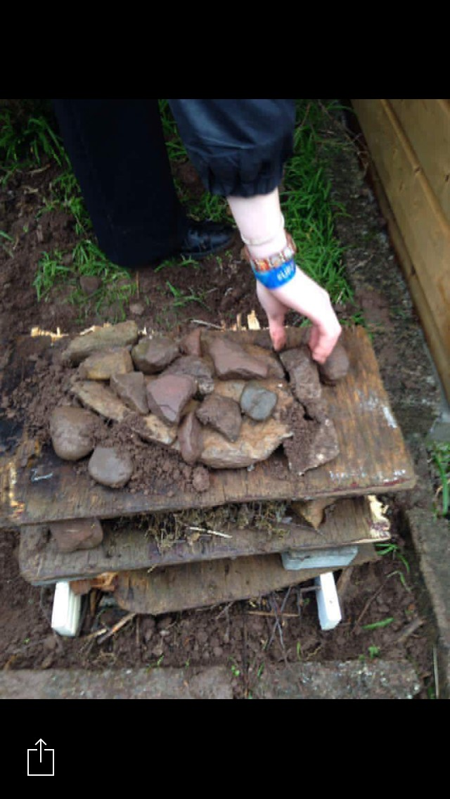
Stage 5: For the final layer we used rocks.
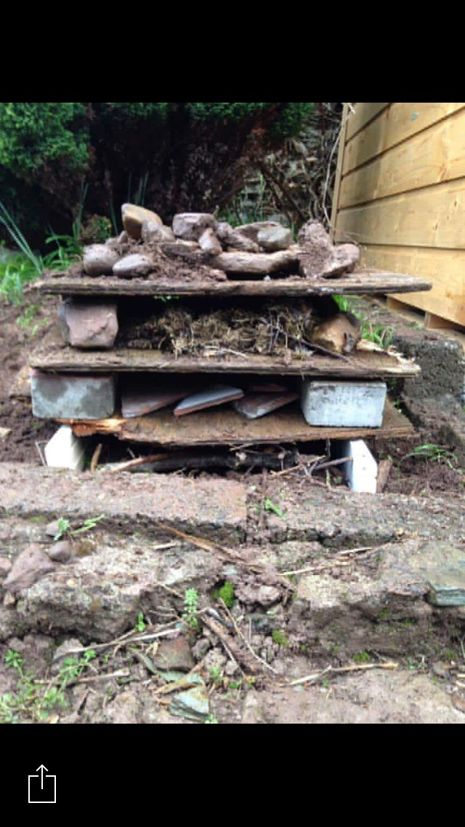
The finished product! ☺

